check5

# Question 1

An organic compound "A" on treatment with benzene sulphonyl chloride gives compound $B.B$ is soluble in dil. $NaOH$ solution. Compound $A$ is______________.

$C_{6}H_{5}−N−{\left({CH}_{3}\right)}_{2}$

$C_{6}H_{5}−{NHCH}_{2}{CH}_{3}$

$C_{6}H_{5}−{CH}_{2}{NHCH}_{3}$

$C_{6}H_{5}−CH−{NH}_{2}$

# Question 2

The total number of reagents from those given below, that can convert nitrobenzene into aniline is _______________ (Integer answer)

|  |  |  |
| --- | --- | --- |
|  |  |  |
|  | Raney nickel |  |

# Question 3

Match List I with List II.

| List-I | List-II |  |  |  |
| --- | --- | --- | --- | --- |
| A. Benzenesulphonyl Chloride | I. Test for primary amines |  |  |  |
| B. Hoffmann bromamide reaction | II. Anti Saytzeff |  |  |  |
| C. Carbylamine reaction | III. Hinsberg reagent |  |  |  |
| D. Hoffmann orientation | IV. Known reaction of Isocyanates |  |  |  |

Choose the correct answer from the options given below:

1. A-IV, B-III, C-II, D-I
2. A-IV, B-II, C-I, D-II
3. A-III, B-IV, C-I, D-II
4. A-IV, B-III, C-I, D-II

# Question 4

Consider the following sequence of reaction :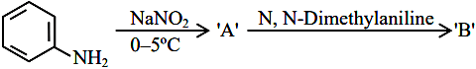product ’ ’ is :

1. image
2. 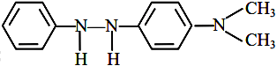
3. 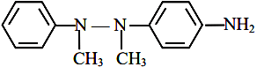
4. image

# Question 5

The correct order in aqueous medium of basic strength in case of methyl substituted amines is :

${Me}_{2}NH>{MeNH}_{2}>{Me}_{3} N>{NH}_{3}$

${Me}_{2}NH>{Me}_{3} N>{MeNH}_{2}>{NH}_{3}$

${NH}_{3}>{Me}_{3} N>{MeNH}_{2}>{Me}_{2}NH$

${Me}_{3} N>{Me}_{2}NH>{MeNH}_{2}>{NH}_{3}$